AIoT Korea Exhibition 2026
Nov. 3(Tue) - Nov. 5(Thu) 2026 / COEX, Seoul, Korea
1. Exhibitor information
Company Name
President
Address | Zip Code ( )
Tel |  |  |  |  | Country
Website | www.
Contact Person |  |  |  |  | Job position
E-mail |  |  |  |  | Direct number

2. Booth type & Price Information [1booth : 3mx3m= 9sq.m.]
Booth Type | Raw Space  (Min. size 2 booths) | Shell Scheme Package  (Min. size 1 booth)
Regular Rate | USD 2,700 / 1booth | USD 3,000 / 1booth
Early-Bird discount | USD 2,430 / 1booth | USD 2,700 / 1booth
※ Early-bird Discount: until May 15, 2026.
3. Participation Fee for Exhibitions Space
Booth Type | Booth Quantity |  | Total
▪ Raw Space |  | Booth(s) | USD
▪ Shell Scheme Package |  | Booth(s) | USD
※ VAT may apply depending on the country.
4. Products to be exhibited

5. Payment Schedule
The Exhibitor agrees to the following payment Schedule :
- The deposit(50% of the total amount) should be paid within 7 days.
- The remaining balance should be paid no later than September 18(Fri), 2026.

Name |  |  | Title |  | Date
Authorized Signatory
& Company Stamp

AIoT Korea Show Management Office l T. +82-2-555-7153 E. aiot@kiot.or.kr

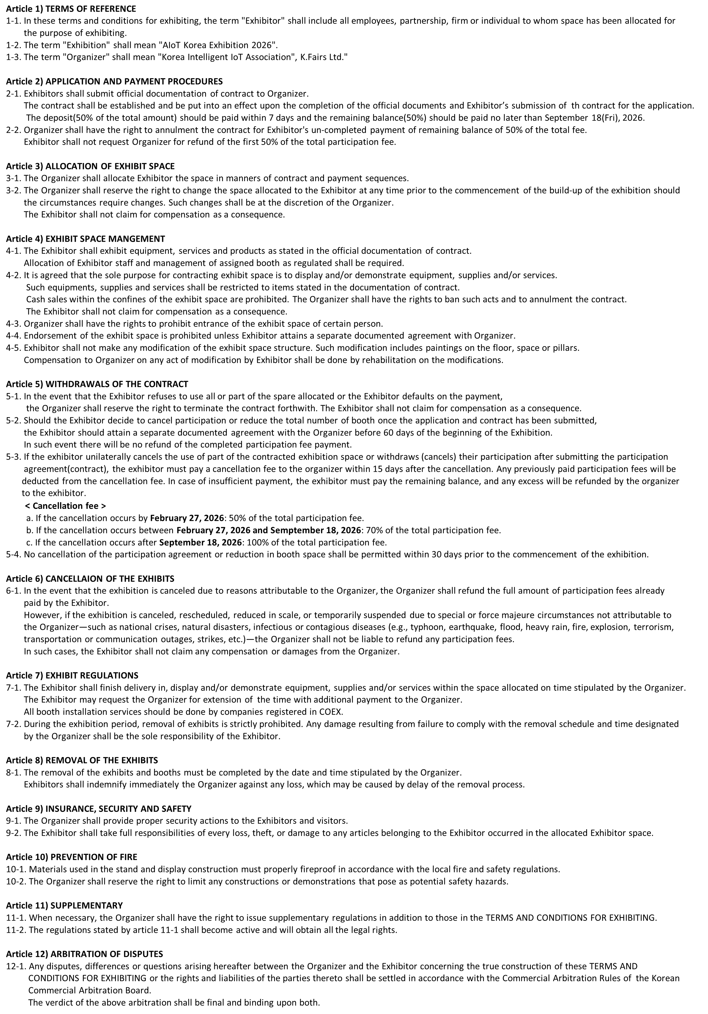
AIoT Korea Show Management Office l T. +82-2-555-7153 E. aiot@kiot.or.kr

